**Jenkins Pipeline for Sonarqube Project**

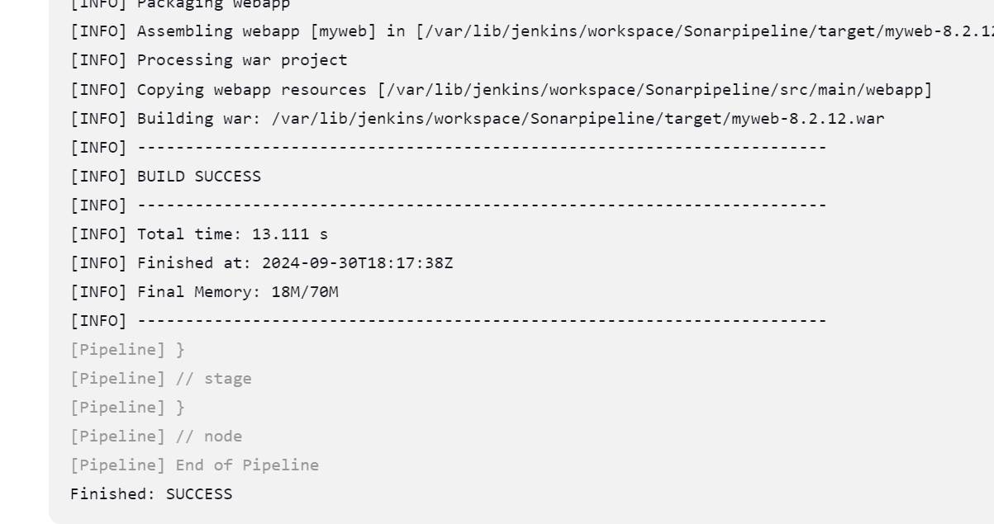

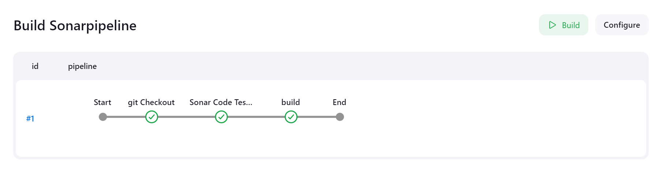 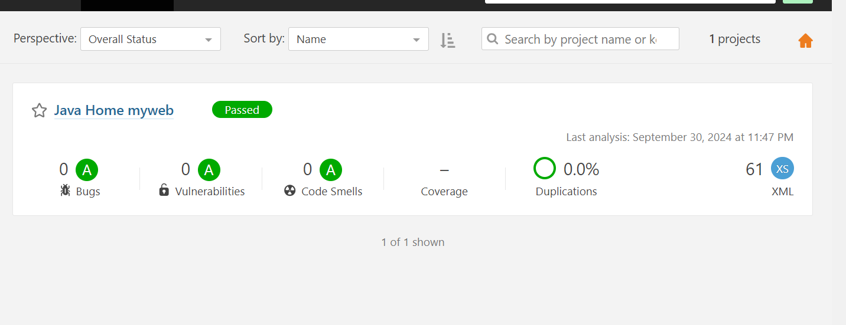

Jenkins pipeline for sonaqube testing (code quality check)

pipeline {

agent any

stages {

stage('git Checkout') {

steps {

git 'https://github.com/PrajaktaGi/myweb.git'

}

}

stage('Sonar Code Testing') {

steps {

sh 'mvn sonar:sonar'

}

}

stage('build') {

steps {

sh 'mvn clean package'

}

}

}

}